**Project Design Phase-II**

**Data Flow Diagram & User Stories**

|  |  |
| --- | --- |
| Date | 03 October 2022 |
| Team ID | PNT2022TMID43406 |
| Project Name | Project - xxx |
| Maximum Marks | 4 Marks |

**Data Flow Diagrams:**

Data Flow Diagrams (DFD) are a common visual representation of how information moves through a system.

A tidy and understandable DFD can graphically represent the appropriate quantity of the system demand.

It demonstrates how information enters and exits the system, what modifies the data, and where information is kept.

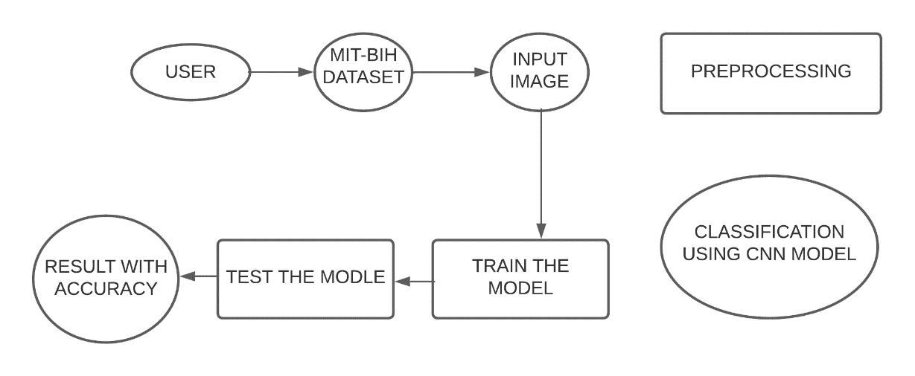

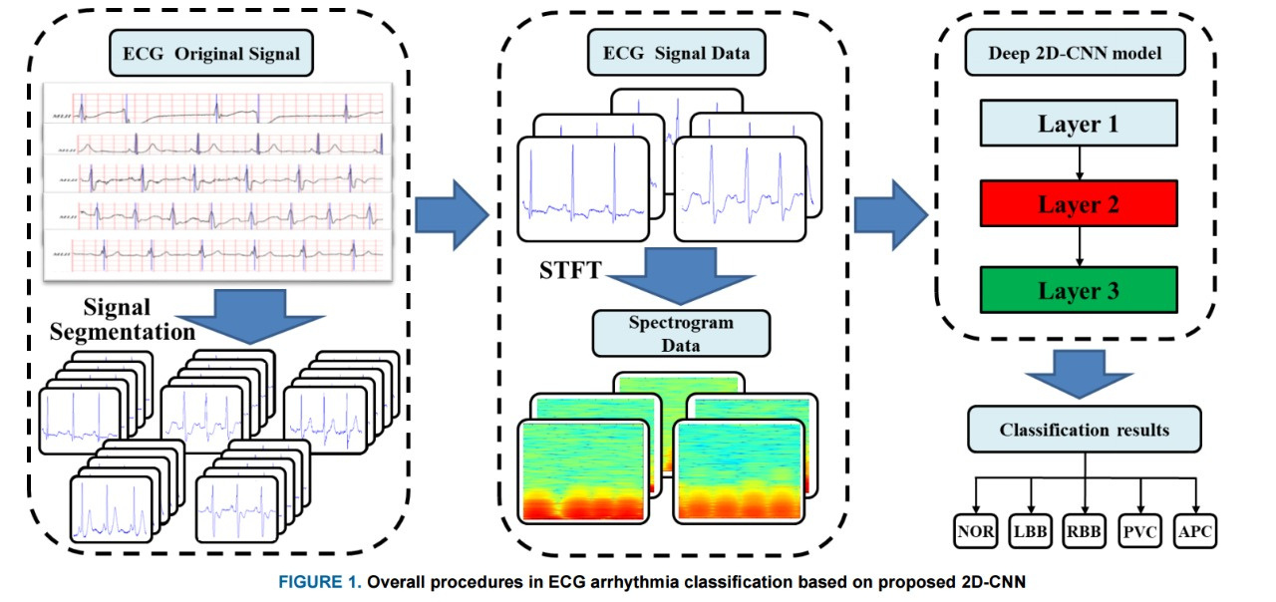

**User Stories**

Use the below template to list all the user stories for the product.

| **User Type** | **Functional Requirement (Epic)** | **User Story Number** | **User Story / Task** | **Acceptance criteria** | **Priority** | **Release** |
| --- | --- | --- | --- | --- | --- | --- |
| Customer/Patient  (Web ) | Website Introduction | USN-1 | As a user, I would be to enter the application and read about the information of cardiovascular diseases and the effects of undetected arrythmia | I can access dashboard | Low | Sprint-1 |
| Customer/Patient  (Web ) | Website Introduction | USN-2 | As a user, I would be able to identify different types of arrythmia in the application. | I can access dashboard | Low | Sprint-1 |
| Customer | Image selection | USN-3 | As a user, I can choose image files from my system and give as input into the application. | I can access website and choose files from my system | Medium | Sprint-2 |
| Patient | Prediction | USN-4 | As a user, I can find out about the condition of my heart beat as Left Bundle Branch Block | I can access the model and predict my arrythmia type. | High | Sprint-3 |
| Patient | Prediction | USN-5 | As a user, I can find out about the condition of my heart beat as Normal | I can access the model and predict my arrythmia type. | High | Sprint-3 |
| Patient | Prediction | USN-6 | As a user, I can find out about the condition of my heart beat as Premature Atrial Contraction | I can access the model and predict my arrythmia type. | High | Sprint-3 |
| Patient | Prediction | USN-7 | As a user, I can find out about the condition of my heart beat as Premature Ventricular Contraction | I can access the model and predict my arrythmia type. | High | Sprint-3 |
| Patient | Prediction | USN-8 | As a user, I can find out about the condition of my heart beat as Right Bundle Branch Block | I can access the model and predict my arrythmia type. | High | Sprint-3 |
| Patient | Prediction | USN-9 | As a user, I can find out about the condition of my heart beat as Ventricular Fibrillation | I can access the model and predict my arrythmia type. | High | Sprint-3 |
| Doctor/Patient | Outcome | USN-10 | As a user, I can find the results and preventive methods of my condition | I can access dashboard | Medium | Sprint-4 |
|  |  |  |  |  |  |  |
|  |  |  |  |  |  |  |